Miscoe Hill PTO Meeting Minutes

Date: 09/16/2022 | Location: Miscoe Library
Called by: Victoria Wilkinson | Time:6:34

Attendees: Victoria Wilkinson (President), Kelly Lucier (Treasurer), Jessica Tilley (Vice President), Tara Corcoran (Secretary), Gina McFadden (Cultural Arts Chair), Diane Duncan, Joseph Bonapace, Deb Lane, Amanda Esquilin, Stephanie Freeman, Erin Valcourt, Laura Davenney, Amanda Esquilin, Krystal Myers, Melissa Morse

Call to Order
Approve Minutes (Recording Secretary) : NA

Opening Reports
President’s Report: Victoria Wilkinson
- Welcome everyone
- Introductions Victoria, Amanda, Joe, Diane, Deb, Krystal, Kelly, Jen, Gina, Stephanie, Melissa, Tara, Erin, Jessica
- Diamond painting- Deb L – Looking to do a community/family event to make the llama or bird “diamond painting”. Would be $5 donation per family to make a llama or bird craft buddy and leave with pen and the buddy. Theme would be Friendsgiving – give to a friend or family. 2 hour community event. Will form a committee to plan specifics. Date TBD.
- Raffle license-yearly $20 – Vicky is proposing to get one every year to allow PTO to do Superbowl Squares and other events such as 50/50 raffle. Voted on – Yes.
- State of Massachusetts currently allows non-profits to have meetings over Zoom.
- School is in need of Substitute teachers.
Treasurer’s Report: Kelly Lucier
- Accounts overview
  - Proposed Budget attached
  - Kelly started a budget based on information she looked at from past 2 years
  - Want to add back Cultural Events. Budgeted $4000 for now
  - Proposing to do review in January and update as needed
  - This is completely separate from We Care Miscoe
  - Budget sets aside money for Mind Your Mind, Nature’s Classroom, Good Neighbor program (providing kids with supplies they might need.
  - PTO currently have basic insurance because we haven’t had events the past couple years. Once we host event, we need to upgrade.Will be an additional $200 for the year. Starts the day we sign up for additional coverage.
  - Jessica motioned to approve budget. Budget approved
Principal’s Report: Jennifer Mannion
  - Much different and better start to this year.
  - Started with an all school meeting. Greeting, sharing of news, fun/engaging piece.
  - Grade level meetings reviewing expectations
  - Open House this week. Early this year.
  - Lot of staffing changes. Very fortunate in our hires. In 6th grade math hired 2 great veteran math teachers. Jeremy Mulligan, Kevin McNeil. Bortolotti, Spec Ed, Johnson, Brosnihan, Nadine Carter, Donna Shaleli, spanish, para educators. Shift to add Wellness Teacher. Had only 1 previously. Still looking for para-educators. Pool is small.
  - Mini grants
  - We Care projects have transformed Miscoe.
  - Student Advisory Council that gets student input started last year. First meeting tomorrow.

Agenda
Old Business- Unfinished
- Review of Miscoe PTO Bylaws and proposed changes
  - Last updated 2014
  - See attached document outlining changes
  - Kelly made motion to approve. Proposed changes approved.
- Recap
  - 5th Grade Popsicle Social-(Tara and Kelly)
    - Map might be helpful to go with scavenger hunt. Jenn said the student council is going to rewrite scavenger hunt.
    - Can scavenger hunt be emailed out to incoming 5th graders in case some can’t make it.
    - Root beer popsicles were not popular.
    - Kids felt like they had to complete the entire scavenger hunt in order to get popsicle.
  - School Kits feedback-(Any/All)
    - No complaints.
    - Will stay with the same company.
    - Recommendation to check contract early to get a discount.
    - If all 3 schools combine we could get a bigger discount? Elementary schools have already signed their contracts.
    - Lindsay will help with School kits for next year.
    - Add to agenda for next month about follow up for School Kits.
    - Can list be updated for people shopping on their own to let people know if colors, etc matter?
    - Is it possible to have 1 teacher per grade be supply list coordinator? There is a coordinator per grade that rotates each month. Jenn recommends we ask in Jan or Feb.

New Business- Ideas, Motions, Announcements
- Fundraising
  - Spirit Wear- social media and email push from office
    - Going on until Sept 25. Currently have 18 items sold. Want to make sure everyone knows about it. Went out in the newsletter today.
    - Jenn said we used to get samples and that motivated kids. And, having it around the holidays.
    - Potentially changing companies to SquadLocker. The new company has more options and can keep open all year. Get product when you order.
    - Is there anyone interested in running spirit wear? Ask at Open House? Amanda offered to run. Thank you!!!
    - Look into combining all 3 schools to get a discount?
  - Fall Fundraiser - Meadow Farms with Money for Miscoe
    - Meadow Farms Catalog fundraiser combined with Money for Miscoe sheet. Catalogs go home with a sheet about Money for Miscoe and an envelope. Runs from Oct 5 – Oct 26.
    - Vicky would like to do something more creative going forward. One fundraiser in Fall and one in Spring.
    - What percentage does Meadow Farms offer back? Maybe add to the letter – if you shop we get his percentage, if you send money we get 100%.
  - If anyone has any ideas, small or big. Would be great if we had a committee so we could bring in more than is currently in the budget to support the school and teachers.
  - Dairy Queen Fundraisers-Vicky
  - Chefs Night Out-Kelly. Beth Devrix is going to set up with local restaurants.
  - Super Bowl Squares – Stephanie. You buy a square and you get randomly assigned to a square. Combined fundraiser with Memorial. She is checking with Town Clerk about legalities. Is this considered a 50/50 raffle? Do we cap at $249 to avoid required reporting for prizes above $250? Do we do gift cards as prizes? Does it matter if 2 towns are involved? Online company that runs it? Joe offered to provide some information on the service.
  - There is a fundraising calendar that coordinates all organizations fundraising to make sure things don’t overlap.
  - Worcester Railers. If you do chorus event, can get percentage. Can do event where when parents buy tickets they get a free ticket, chuck a puck, stuff for raffles. Try to do a combined event with music boosters and athletic boosters and split proceeds..
  - Do WooSox or Railers have any fundraising opportunities? Stephanie will research.
  - Vicky is going to check with chorus teachers and see how they feel.
  - Urban Air night?
  - Set up sign up genius for ideas we’ve come up with and send out with brief description for people to sign up to help/run the events.
- Appreciation Days
  - Form a committee if possible. Deb will lead the committee.
  - Deb proposing a general appreciation for September – appreciate everyone this month. Signup genius for people to sign up and bring items in. Want to include everyone – bus drivers, librarian, etc. Was thinking of September 30 for an appreciation event. Conference day before Veteran’s Day. Too much traffic. Oct 8 is PD day.
  - Looking for members for the Appreciation Committee.
  - Kelly proposed that we should try to budget out appreciation for the year to enhance donations. Shout outs on certain days and inclusive on other general occasions.
  - Deb will be head of the appreciation committee.
  - Vicky would like to follow a calendar of appreciation.
  - IT professional day is Sept 21 (Mr. Quinn and team?)
  - Custodian Day Oct 2?
  - Can we use tvs around the school? Yes
  - In the past, kids have done banners. Have done coffee and donuts for bus drivers.
  - Jenn likes the idea of focusing on specific groups because some groups get overlooked.
  - In addition to Teacher Appreciation week, will make sure to invite everyone.
  - Angela has a full list of everyone working at the school.
  - Krystal, Amanda will be on the committee. Thank you!!!
  - Vicky will share all the appreciation days with the committee.
  - It was agreed that instead of doing a general appreciation event this month we will start with something for IT Professional day since we did the general thank you the first day of school..
- Other Business
  - When is the October meeting because it falls on Columbus Day? Will have on Oct 17
  - Do we want to stay in the library? Teacher’s lounge is getting booked up. Yes, will continue to have meetings in the library.
  - When the meeting is in newsletter, please include time of meetings.
  - Social media activity is super helpful.
  - PTO will have a blurb in every newsletter.
  - Book Fair
    - Week of Nov 7
    - Can deliver week before
    - How has it been done in the past. Usually done during day and then if there is evening event it is open then too. If there is time, nice to have a preview day for kids. Historically, done around $7,000.
    - Has been done in library and upper gym.
    - We will reach out to school media center coordinator.
    - Set up Tuesday, Wednesday, Thursday for kids to cycle through.

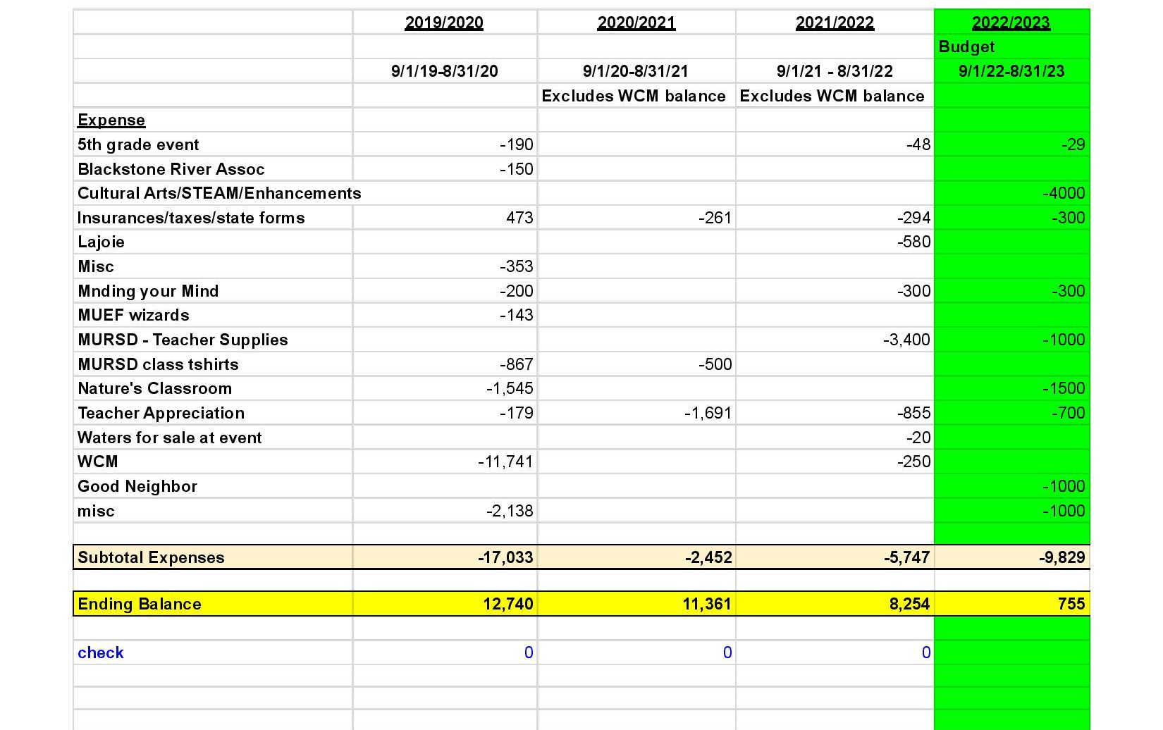
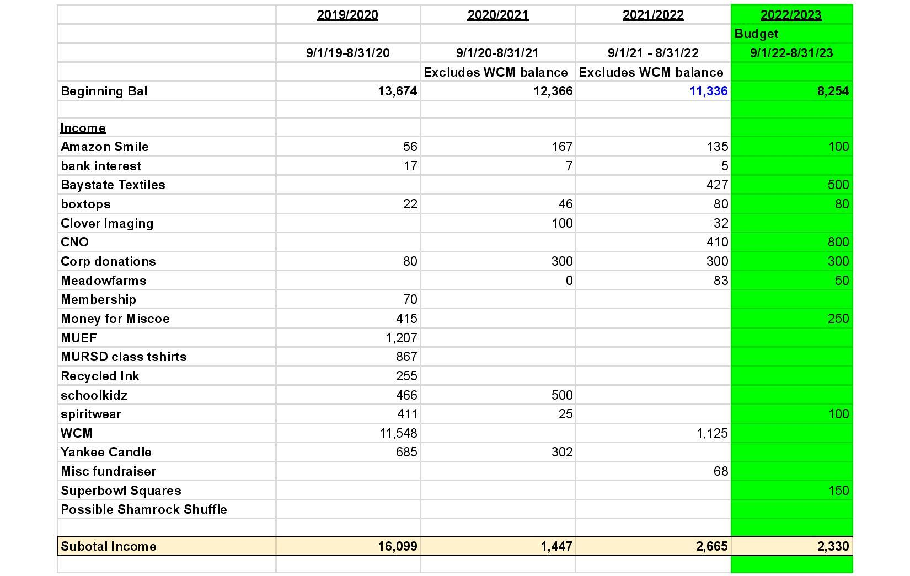

Operational Bylaws for
Miscoe Hill Parent Teacher Organization

Article
I. Name
- The name of this Organization shall be the Miscoe Hill Parent Teacher Organization (Miscoe Hill PTO).

II. Mission Statement
- The mission of the Miscoe Hill Parent Teacher Organization (Miscoe Hill PTO) is to enhance the educational and social experiences that our children have at Miscoe Hill School by enriching the curriculum and providing the school community with social activities through the support and participation of our parents and teachers.

III. Purposes and Roles
- Purpose: To provide the Miscoe Hill School Community with leadership and financial support for:
- Curriculum enhancing programs
- Classroom enrichment
- Social activities
- Families in need for academic programs and school-related activities in the form of aid or scholarships.
B. Roles
- Plan and implement cultural arts/curriculum enhancing programs
- Organize volunteers
- Provide educational and enrichment materials and equipment
- Sponsor social activities

IV. Financial Sources and Support: The Miscoe Hill PTO is responsible for raising the funds that support the purposes and roles of the organization. Financing and support for the Miscoe Hill PTO can come from any of the following:
- Corporate reward programs
- Fundraising activities
- Grants
- Donations

V. Membership and Dues
- Membership: Membership is open to any parent, legal guardian or school personnel in the Mendon Upton School District.

VI. Executive Board
- The Executive Board is made up of all Officers. The Executive Board is responsible for managing the affairs, activities and operation of the Miscoe Hill PTO. They shall transact necessary business during the intervals between meetings of the membership and other such business as referred to in these bylaws.
- No member shall be allowed to hold more than one Executive Board position at one time.
- In accordance with Massachusetts general laws for non-profit corporations, the organization must have a President, a Treasurer, and a Secretary to operate.
- Regular meetings of the Executive Board shall be held during the year, the time to be established at the first Executive Board meeting in August, at which time the Executive Board shall familiarize themselves with the current Bylaws. Special meetings may be called by the President or by a majority of the Executive Board.
- Members of the Executive Board are expected to attend eight or more executive board meetings and eight or more general membership meetings per year unless prior arrangements are made. (see ITEM VII section C.)
- Quorum: A majority of the regular members of the Executive Board shall constitute the Quorum for any matters requiring a vote.

VII. Officers and Roles
- Officers: The officers shall oversee all business of the Miscoe Hill PTO between its meetings, set the hour, day and place of all meetings, make recommendations to the Miscoe Hill PTO membership, update appropriate job descriptions, and perform other duties outlined in these bylaws. The officers of the Miscoe Hill PTO shall include:
- President
- Vice President
- Secretary
- Treasurer
- Cultural Arts Chair
- Fundraising Chair
- Volunteer Coordinator
In the event that an individual is unable or unwilling to serve in an officer position alone, co chairs/co-officers are acceptable within all other guidelines outlined in these bylaws. The President is an exception to this co-officer opportunity per current State law. The Treasurer is also an exception to this co-officer opportunity, since it is critical to have one person responsible for the financial activities of the organization.
- Roles
- President: The President will preside at all organization and Executive Board meetings. He/she shall be a member ex-officia of all committees. The President shall have the power to appoint a chair or hold election for all chairpersons nominated from the floor. He/she shall provide a written summary of the Miscoe Hill PTO activities at the annual, year-end Executive Board and General Membership meetings. The President shall have such authority as generally invested in the office, by correct parliamentary procedures. According to Massachusetts General Law, "Co-President" Officers are not permitted.
- Vice President: The Vice President shall assist the President in all his/her duties and shall be the presiding officer in the absence of the President at member and Executive Board meetings. He/she shall be the Chairperson of the Nominating Committee and shall announce the results of the elections and introduce the newly elected officers at the June meeting. He/she shall be the Chairperson of the Bylaw Committee, and will reconcile bank statements four times per year.
- Secretary: The Secretary shall be responsible for recording, reporting and maintaining a record of the minutes of the Executive Board and monthly member meetings. He/she shall be responsible for handling all correspondence and maintaining copies of all written reports. The Secretary will ensure that a Newsletter is distributed at the Executive Board's discretion
- Treasurer: The Treasurer will be responsible for maintaining and recording all organization and related funds for distributing funds as authorized by the Executive Board and for preparing and presenting a budget for the fiscal year. He/she will issue a finance report at the monthly member meetings. This report will include an actual balance detailing expenditures, deposits and commitments. Detailed records shall be kept and copies of necessary information shall be made available to the Cultural Arts Chair for cultural arts/curriculum enhancing activities. The Treasurer is responsible for ensuring all financial information is made available to an accountant at the end of the school year and for ensuring the filing of all appropriate and required tax records in accordance with the current IRS Tax Laws. He/She is also responsible for ensuring filing of all appropriate Organization documents with the Secretary of State.
- Cultural Arts Chair: The Cultural Arts Chair is responsible for all cultural arts and enrichment programs, and for overseeing the Cultural Arts Committee, should one exist, according to the Committee Guidelines found in ITEM IX. The Cultural Arts Chairperson has the authority to contract programs on behalf of the Miscoe Hill PTO. This authority is within the following guidelines:
  - Solicit input: Solicit faculty input on programs that support and enhance the curriculum goals for the year. The programs should encompass a well-rounded representation of educational topics. These topics should be parallel with those being presented in the yearly curriculum. Any topics, which might be construed as controversial, will be presented to the general membership for discussion.
  - Evaluate programs: Evaluate programs through personal visit or reference checking.
  - Contract within funding guidelines: Contract the program on behalf of the Miscoe Hill PTO within the financial guidelines set forth.
    - The budget for this committee shall be decided upon annually by the Executive Board and is subject to available funds. Other funds may be added to this committee's budget if they are available and based upon a vote by the general membership.
    - The expenditure per program is left to the discretion of the chairperson and the committee, as long as sufficient nmds are available.
  - Expenditures must cover all grades fairly
  - Apply for grants
    - The Cultural Arts Chair will apply to the appropriate cultural councils and all other relevant organizations for grant money on all applicable programs.
    - Any funds received from these grant requests or applications shall be added back into the cultural arts fund.
- Fundraising Chair: The Fundraising Chair is responsible for raising funds to maximize support for the Organization's previously stated purposes and roles. The Fundraising Chair shall oversee the Fundraising Committee, if one exists, according to the Committee Guidelines found in ITEM IX. Fundraising responsibilities also include:
  - Investigating available fundraising programs to determine which most closely match the financial goals and purposes of the Miscoe Hill PTO.
  - Implementing all programs with the support of Miscoe Hill PTO volunteers including, but not limited to:
    - Sourcing all fundraising materials and pamphlets.
    - Distributing all materials to the school community.
    - Collecting all orders.
    - Managing all funds that come in as a result of the fundraising activity.
    - Reporting and delivering all funds to the Treasurer, including daily tape and/or spreadsheet totals.
    - Distributing all orders from the fundraising program.
  - All money to be turned in to the Treasurer within 48 hours of collecting.
  - All checks turned into Treasurer must be stamped FOR DEPOSIT ONLY prior to submission.
  - All funds must be counted by two or more people excluding the Treasurer.
  - Managing the Book Fair currently falls under the responsibility of Fundraising Chair, however this can be changed as deemed necessary by the Executive Board.
- Volunteer Coordinator: Volunteer Coordinator is responsible for all activities required to encourage the participation ·of volunteers, providing information to committees regarding volunteers who are interested, assisting in the follow up notification of volunteers and any other related duties that encourage and coordinate participation in the Miscoe Hill PTO.
C. Resignation, Removal and Vacant Positions:
- Any officer or chairperson may resign by submitting their resignation in writing.** Any Miscoe Hill PTO property must be returned to the Executive Board upon resignation. The Nominating Committee shall fill any vacancy in office because of death, resignation or inability to serve for the unexpired portion of the term. However, should a vacancy occur in the office of the President, the Vice President shall assume the President's responsibilities until a new President is elected by general membership (see ITEM VIII - Elections).
- Any officer may be removed from office by the affirmative vote of two thirds of the Executive Board at any regular or special meeting called for that purpose. Removal from office may occur because of conduct detrimental to the interest of the Miscoe Hill PTO, lack of sympathy with its objectives, or for refusal to render reasonable assistance in carrying out its purposes. Any officer proposed to be removed shall be entitled to at least five days written notice of the meeting of the Executive Board at which such removal is to be voted upon and shall be entitled to appear before and be heard by the Executive Board.
D. Salary: No member, officer or Executive Board member shall receive a salary as a result of his or her work for the Miscoe Hill PTO. However, Executive Board members may be reimbursed for out of-pocket expenses made on behalf of the Miscoe Hill PTO and approved by the Executive Board according to expenditure guidelines in these bylaws.

VII. Elections
- Eligibility: Executive Board positions shall be open to any member who has attended at least two monthly meetings during the current school year. However, a majority vote of the general membership will allow a member to be exempt from the two monthly meetings if that member is in good standing. Parents and legal guardians of incoming students enrolling in the MURSD in the upcoming school year are also eligible to run for an Executive Board position for the upcoming year, but are exempt from meeting attendance requirements mentioned above.
- Process: Except as noted, all officers are nominated by the Nominating Committee or from the floor at the April meeting of each year. The election will be held every year at the May meeting. Election to be decided by majority vote. If a candidate cannot attend the nominating meeting a written acceptance letter must be submitted to the Vice President.
- Terms and Limits: New officers shall take over their duties after the June general PTO meeting. Terms of office for all Officers shall be one year.

IX. Committees: Committees may be created on an annual basis by the President, the Executive Board, and/or recommendations from the general membership. Committees exist to support the purpose of the organization and only if the volunteer participation is at the appropriate level to support the needs of the committee as deemed by the committee chairperson. Committees shall be created for a specific time and/or task and shall cease to exist when that time or task is completed. Committee chairpersons shall recruit members for the committee with the assistance of the Volunteer Coordinator. The chairperson is responsible for all functions of their committee and shall report the plans and activities of the committee to the Executive Board, which presents all plans and funding requests to the general membership for approval.
- Nomination Committee: The Nominating Committee is a three-person committee chaired by the Vice President. The Vice President will appoint the other two members of this committee in February. The Nominating Committee is responsible for receiving all suggestions for persons to serve as officers. The committee shall prepare a slate of officers to present for election by the membership. This committee shall contact all persons who will be nominated to confirm their willingness to serve.

X. Meetings
- General Membership Meetings: shall be held on a regularly scheduled, monthly basis to be set forth at the first general membership meeting of the year. The first meeting of the year will be in September, the date of which will be set by the Executive Board.
- Notification: Members are notified of meetings and agendas through a wide range of available resources, such as: verbal notice at the general meetings, written notice in the Miscoe Hill PTO Newsletter, and on the Miscoe Hill PTO website. The means used to communicate the meeting schedule may change based on resources available, however all appropriate effort will be taken to ensure the general membership is aware of the meetings.
- Agendas: The agenda for the monthly meeting is posted prior to the scheduled monthly general meeting and can be communicated through such resources as email and on the Miscoe Hill PTO website. This agenda is subject to change through the time of the meeting. Any member may have items placed on the agenda provided they are submitted to the President prior to the scheduled meeting.
- Executive Board Meetings: will be held prior to the monthly general membership meeting.
- Committee Meetings: will be held anytime deemed necessary by the committee chairperson(s).
- Specific Meeting Requirements
- Start of year business: At a minimum, the following two items will be covered as part of start of year business:
  - Determination of and sign up for committees
  - Review the estimated budget for the coming year
- October: meeting will include verification of: filing of all appropriate tax documents as required by the IRS and the Commonwealth of Massachusetts.
- April: the annual Bylaw review will be conducted.
- May: conduct elections of officers for the coming year.
- June: at the end of the operating year, the Executive Board will hold an annual meeting for the purpose of reviewing the annual report of the Miscoe Hill PTO and other end of year business. This meeting shall include, at a minimum, the following topics:
  - End of year business
  - Financial report of the Organization including assets, liabilities, donated funds, expenses, and disbursements of the Miscoe Hill PTO at the end of the fiscal year. (Year End Report)
  - Filing status of required items (taxes, annual report, etc.)

XI Voting
- Quorum: Those persons present at a properly called General Membership or special meeting shall be designated a quorum and shall be entitled to take action on behalf of the Organization.
- General Membership Voting: All motions carried by majority vote shall be binding to all members.
- Electoral Voting: In order to be eligible to vote at the May elections, the attendee must have attended at least two general meetings during the current school year.
- Phone/Email Voting: An Executive Order was issued by Governor Baker on March 12, 2020 that allows public bodies to continue holding meetings remotely without a quorum of the public body physically present at a meeting location, and to provide “adequate, alternative” access to remote meetings. The State has extended authorization for virtual public meetings through July 15, 2022. In accordance with this order, electronic voting is considered to be valid.
- All officers shall have the right to vote on any motion presented.

XII Bylaw Amendments: These bylaws may be amended by submitting in writing the proposed amendment to the Executive Board for presentation to the general membership. The proposed amendment shall be voted on at the following general membership meeting. A two-thirds vote of the membership present is necessary for the amendment to be adopted. A copy of all incorporated amendments will be recorded by the Secretary and posted in the Meeting Minutes.

XIII Expenditures and Finances
- Budget: By October, the Executive Board shall present to the membership, for their approval, a budget of anticipated revenue and expenses for the year. This budget shall be used to guide the activities of the Executive Board during the year. The members must approve any substantial deviation from the budget, in advance.
- Expenditures: Only motions carried by majority vote may be funded with Miscoe Hill PTO funds. Funds will be expended for only school-related activities and/or interests that the organization deems necessary.
- Requests: Requests for funds can be made at any point during the school year with the understanding that voting will occur at the monthly meeting, barring extenuating circumstances such as time constraints and deadlines.
- When necessary, the Executive Board will verify with the Principal if a proposed expenditure falls under school budget jurisdiction and whether the funds for such are available, before that expenditure is discussed at the Miscoe Hill PTO meeting.
- Any organization-related expenditures up to $500 that may arise and require action between meetings may be spent at the discretion of the Executive Board. A full account of such expenses will be made at the following monthly meeting.
- A majority vote of the attending membership is required to approve any expenditure over $500.
- Items may be voted contingent upon funds being available. No contract may be entered into until funds are in account.
- Receipts for approved expenditures must be received prior to the end of the school year.
- Special funding: Available funds will be given any time to assist any student who is unable to finance any curriculum-based activity (i.e. field trips, classroom materials, etc.). Approval of such funds requires notification of the Executive Board. The request for these funds will be validated by the guidance department and/or administration. Confidentiality is to be maintained in all matters and names of the recipient are not to be released in any voting process or in any manner, at any other time.
- Books and Records: The Miscoe Hill PTO shall keep true, exact and complete books of account in which each and every transaction of the Miscoe Hill PTO is entered fully and accurately. The Treasurer shall keep all books and records and all Executive Board members shall have the right to inspect and review such books.
- Fiscal Year: The fiscal year of the Miscoe Hill PTO is September 1 to August 31, having all tax filings in accordance with the IRS and State of Massachusetts regulations.
- Financial Reports: An accounting shall be made at the end of the operating year, with estimates for income and expenses projected but not yet received and presented at the May meeting. A final accounting shall be made at the end of each fiscal year and a copy of the accounting report shall be made available to each member as well as appropriately filed with the IRS in accordance with 501(c)(3) tax laws of the United States at3:d the Commonwealth of Massachusetts.
- Bank Accounts: All funds of the Miscoe Hill PTO shall be deposited in such bank account(s) as designated by the Executive Board. Withdrawals from any such bank account(s) shall be made upon such signature or signatures as the Executive Board may designate and be made only for the purposes of the Misoe Hill PTO as outlined in these bylaws.
- Signing Authority: The President and Treasurer retain all signing authority for the Organization.

XIV Dissolution of the Miscoe Hill PTO
- Dissolving this Organization can be voluntary (by vote) or involuntary (due to lack of compliance). In accordance with Massachusetts general laws for non-profit corporations and the Miscoe Hill PTO Operational Bylaws, the Organization must have a President, a Treasurer, and a Secretary to operate. One person cannot hold more than one of these positions. In the event that these positions are not filled0 consideration should be given to dissolving the Organization.
- Should the organization disband, all Miscoe Hill PTO property will be donated to the Miscoe Hill School. Any funds will go to the Principal's Fund.
- In the event that the Miscoe Hill PTO is split into multiple PTOs, all property and funds will be divided proportionally between the newly formed organizations based on student population.

XV Amendments
April 2014
- The phrase "at any meeting" was struck from the first sentence ofltem VII, Officers & Roles, C, Resignation, Removal and Vacant Positions. Instead, it was intended that this section read, "Any officer or chairperson may resign by submitting their resignation in writing.”
- The phrase "$250" was struck from Item VIII, Expenditures & Finances, B3, and was replaced with the phrase "$500.,, This amendment was made to allow this document to reflect a previous vote taken to raise the discretionary amount the Executive Board may spend between meetings from $250 to $500.

Miscoe Hill PTO
PROPOSED AMENDMENTS
September 2022
V.A. Membership:
- Current: Membership is open to any parent, legal guardian or school personnel in the Miscoe Hill School Community.
- Amended: Membership is open to any parent, legal guardian or school personnel in the Mendon Upton School District.

VII Elections
- Current: Eligibility: Executive Board positions shall be open to any paid member who has attended at least three monthly meetings during the current school year. However, a majority vote of the general membership will allow a paid member to be exempt from the three monthly meetings if that member is in good standing. Parents and legal guardians of incoming students enrolling at Miscoe in the upcoming school year are also eligible to run for an Executive Board position for the upcoming year but are exempt from the dues and meeting attendance requirements mentioned above.
- Amended: Eligibility: Executive Board positions shall be open to any member who has attended at least two monthly meetings during the current school year. However, a majority vote of the general membership will allow a member to be exempt from the two monthly meetings if that member is in good standing. Parents and legal guardians of incoming students enrolling in the MURSD in the upcoming school year are also eligible to run for an Executive Board position for the upcoming year, but are exempt from meeting attendance requirements mentioned above.
VII.B.6.d Fundraising Chair: All checks turned into Treasurer must be stamped FOR DEPOSIT ONLY prior to submission has been deleted as the treasurer has the stamp.

I.X Committees
- Current: Nomination Committee: The Nominating Committee is a three-person committee chaired by the Vice President. The Vice President will appoint the other two members of this committee in February. The Nominating Committee is responsible for receiving all suggestions for persons to serve as officers. The committee shall prepare a slate of officers to present for election by the membership. This committee shall contact all persons who will be nominated to confirm their willingness to serve.
- Amended: Can we delete this?
- If so, will need to update this: VII Elections: Process: Except as noted, all officers are nominated by the Nominating Committee or from the floor at the April meeting of each year. The election will be held every year at the May meeting. Election to be decided by majority vote. If a candidate cannot attend the nominating meeting a written acceptance letter must be submitted to the Vice President.

X.D. Specific Meeting Requirements
- Current: October: meeting will include verification of: filing of all appropriate tax documents as required by the IRS and the Commonwealth of Massachusetts.
- Amended to: By November: meeting will include verification of: filing of all appropriate tax documents as required by the IRS and the Commonwealth of Massachusetts.

XI.C Electoral Voting:
- Current: In order to be eligible to vote at the May elections, the attendee must have paid dues by September.
- Amended to: In order to be eligible to vote at the May elections, the attendee must have attended at least two general meetings during the current school year.

XI.D. Phone/Email Voting:
- Current: For Executive Board business only, phone and e-mail votes can be used as required to ensure the smooth operation and decision making of the Miscoe Hill PTO. The President will contact each Executive Board member within a reasonable time period and present the information required for the vote. The President is responsible for tallying the votes and reporting the results.
- Amended to: An Executive Order was issued by Governor Baker on March 12, 2020 that allows public bodies to continue holding meetings remotely without a quorum of the public body physically present at a meeting location, and to provide “adequate, alternative” access to remote meetings. The State has extended authorization for virtual public meetings through July 15, 2022. In accordance with this order, electronic voting is considered to be accepted.

XIII.A Budget:
- Current: At the first meeting of the year, the Executive Board shall present to the membership, for their approval, a budget of anticipated revenue and expenses for the year. This budget shall be used to guide the activities of the Executive Board during the year. The members must approve any substantial deviation from the budget, in advance.
- Amended to: By October’s meeting, the Executive Board shall present to the membership, for their approval, a budget of anticipated revenue and expenses for the year. This budget shall be used to guide the activities of the Executive Board during the year. The members must approve any substantial deviation from the budget, in advance.

XIII.B.1. Expenditures
- Current: Funding requests should be received at least two weeks prior to the monthly meetings.
- Amended to: Requests for funds can be made at any point during the school year with the understanding that voting will occur at the monthly meeting, barring extenuating circumstances such as time constraints and deadlines.

XIII.B.4. Expenditures
- Current: A majority vote of the attending membership is required to approve any expenditure.
- Amended to: A majority vote of the attending membership is required to approve any expenditure over $500.

XIII.C Books and Records
- Current: Fiscal Year: The fiscal year of the Miscoe Hill PTO is September 1 to August 31, having all tax filings in accordance with the IRS and State of Massachusetts regulations.
- Amended to: Fiscal Year: The fiscal year of the Miscoe Hill PTO is August 1 to July 31, having all tax filings in accordance with the IRS and State of Massachusetts regulations.

IV, V, VII.A., XI.B, XI.C - All mentions of dues/membership fees have been removed. We are hoping to remove barriers in order to increase participation.

